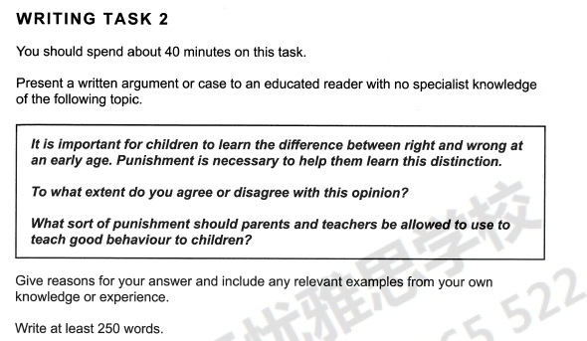

Learning the difference between right and wrong is necessary for students, no matter in school or at home, which is helpful in children’s growing up. Some people assume that punishment is an available method for its directive effect. From my own perspective, punishment sometimes is efficient, but excessive punishment can bring negative influence on kids.

Punishment can prevent children from making similar mistakes in the future. Take myself an example, when I was a child, I stole an eraser from a classmate, as I had never seen such a colorful eraser. Fortunately, my father found that and punished me in a strict way. He shut me in a dark room for a whole day without water and food. After that, he bought me a same one. He told me that stealing things is illegal and I would spend the rest of my life in jail if I were a thief when I grow up. From then on, I haven’t stolen anything.

However, excessive punishment is not necessary in educating children. On the contrary, it spirals bad behaviors and makes simple problems complex. Abusing punishment hurts children in both physics and mental. There were some news reported that that some parents beaten them by sticks when they made small mistakes. Result in children suspected whether their parents loved them. And some even suicide themselves, for the reason that they cannot bare that kind of punishment anymore.

In summary, I suppose that moderate punishment is helpful in teaching children telling right and wrong, while excessive punishment should be forbidden as which may produce far more problems.